INSTRUCTIONS FOR PREPARING
2025 CMPUG Winter Symposium ABSTRACTS

Firstname Lastname¹, Firstname Lastname², and Firstname Lastname³
¹ University or Company, City, State, Zip, Country, email@email.address.com
² University or Company, City, State, Zip, Country, email@email.address.com
³ University or Company, City, State, Zip, Country, email@email.address.com

Abstracts should be kept to one page of text and may include supporting figures. The abstract title should be 14-point bold Arial font and centered on the page. After a 14-point blank line, the author’s name(s) should be listed with first name followed by last name in 12-point Arial font, centered on the page. Author contact information should be in 10-point Arial font, centered on the page, just below the names and should include organization, city, state (or region), postal code, country, and email address.

After a 10-point blank double line, all other text should be 10-point Arial or Symbol font in double column format. Paragraphs should be single spaced and fully justified. Leave a blank line between paragraphs, such as shown in this template. When citing a reference in the text, type the corresponding reference number in square brackets as shown at the end of this sentence [1].

Submissions should be in one of two formats, Adobe Acrobat PDF (strongly preferred because it significantly reduces the file size) or Microsoft Word. Abstracts should be formatted for A4 paper (21 X 29 cm) leaving a 2.5-cm margin on top, 1.5-cm on bottom, and 2.0-cm on both sides. The corresponding author’s name, phone and fax numbers, email address, affiliation, and contact address should be listed after the abstract text. Please indicate (below) the preference of oral or poster presentation and assign the appropriate topic area from the topic list on the ICPT 2025 website.

Abstracts must be submitted by end of day October 31, 2025. Please submit your abstract via email to all three conference co-chairs:
nagella.nukuna@dupont.com
ekaterina_mikhaylichenko@amat.com richard.f.vreeland@intel.com

Corresponding Author (please fill this out!)
Name:
Email address:
Tel:

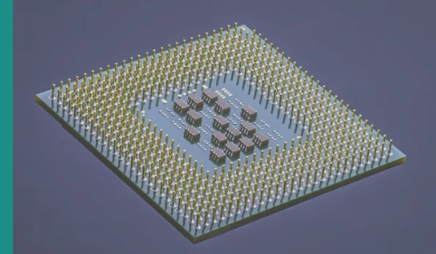

Fig.1 Figure title & short description

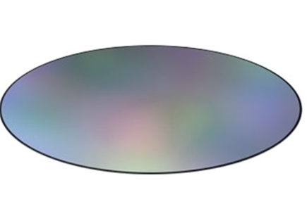

Fig.2 Figure title & short description

